As of 7-19-2017 Here is the link with the survey results : https://www.surveymonkey.com/results/SM-6FQ6CDP3/

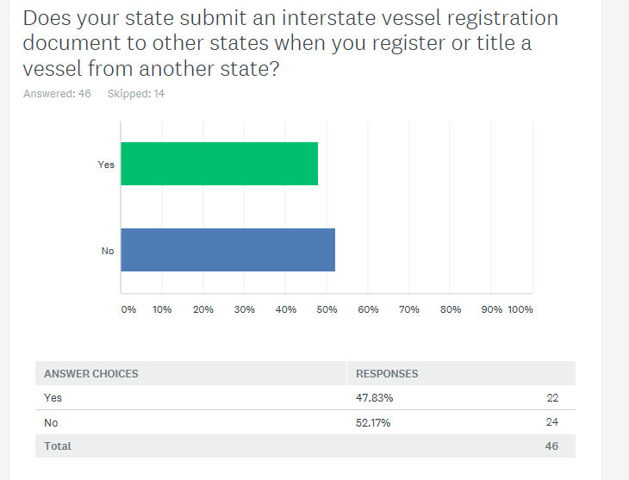

20 states answered “Yes”.
NM OH MA TX OK
KS AZ NV PA VA
UT AL PR NC WI
AZ CO DE NE MS

Called one state since they wanted to know what an interstate report was. Many states skipped this question.
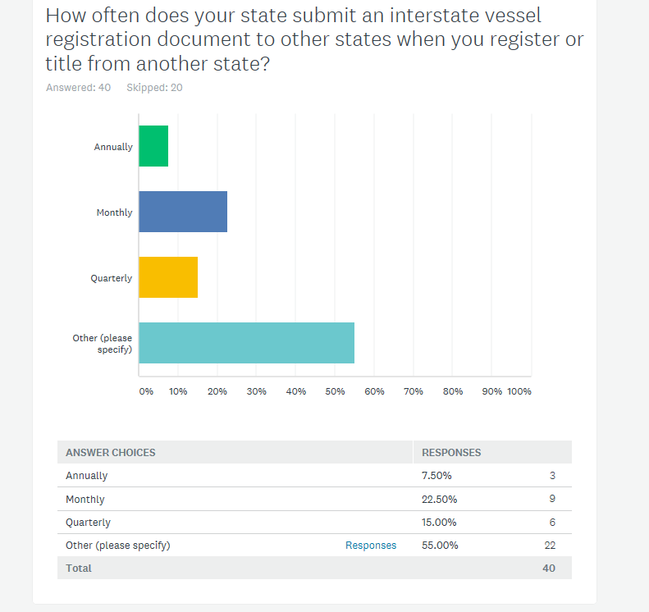

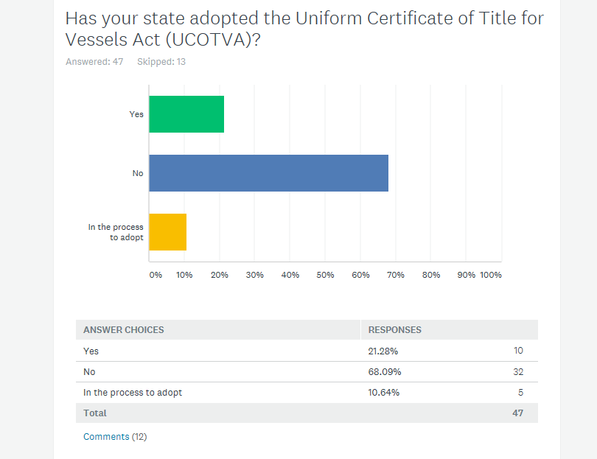

15 respondents answered that their state has adopted or is in the process of adopting UCOTVA.

